**Exercise**

* **Write a  program to detect whether a string by the user is an integer(number) return true or if not return false.**

**Approach:**

**So here we did like this**

**For java : The hasNext() is a method of Java Scanner class which returns true if this scanner has another token in its input.  
So here sc.hasNextInt()method returns true if the next set of characters in the input stream can be read in as an int. If they can't be read as an int, or they are too big for an int or if the end of the file has been reached, then it returns false. hasNextInt() itself does not consume any characters.**

**For Python :** Python String isnumeric() method is a built-in method used for string handling. The isnumeric() method returns “True” if all characters in the string are numeric characters, Otherwise, It returns “False”

**Solution 👇**

**Java :**

**import java.util.Scanner;**

**public class CodeXam {**

**public static void main(String[] args) {**

**System.out.println("Enter your number");**

**Scanner sc = new Scanner(System.in);**

**System.out.println(sc.hasNextInt());**

**}**

**}**

**output:**

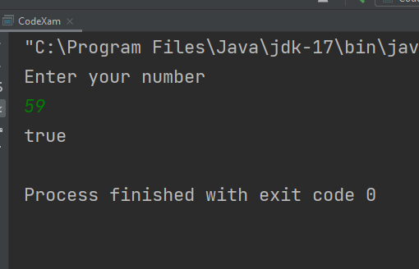

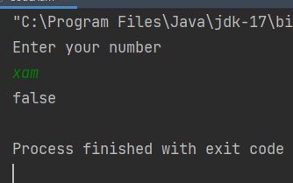

**Python :**

**user_input = input("Enter your number ")**

**print(user_input.isnumeric())**

**output:**

